The Family Review: Children’s Call to Action
Everything you need to know

Who is the Children’s Commissioner?
The Children’s Commissioner for England is Dame Rachel de Souza. She is an independent person chosen by Government to stand up for children’s rights in England.
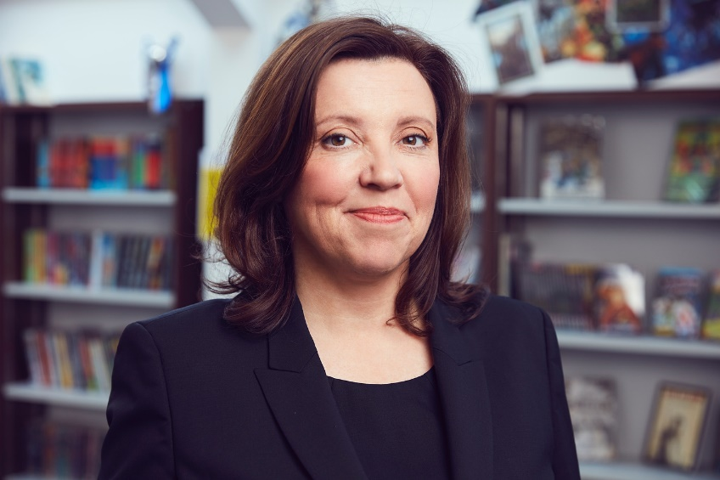
The Children’s Commissioner’s job is to speak up for children in England, and make sure that the people in power listen to what children need and want.
The Children’s Commissioner will use what you tell us to show the government what you think, and what children and their families need to live happier lives.

What is The Big Summer Survey?
The Children’s Commissioner for England, Dame Rachel de Souza, wants to hear from you about the summer holidays. This is to create a unique picture of children’s lives over the summer, how you have spent your time during the holidays, and how this compares to term time. There is very little currently known at a national level about how children spend their time over the summer break and this new research will really add to that picture.
There will be questions about you (like your age and gender). This is to make sure that the results reflect what all children said. The survey will then ask you some questions about how you spent the summer holidays, and the time you spent with your family. We won’t ask for any identifiable information like names or phone numbers, and everything you tell us will be kept completely anonymous.
What is the Family Review?
The Children’s Commissioner is conducting a review of family life in England.
Last year the Children’s Commissioner ran The Big Ask, the largest ever survey of children, in which children told her that family is really important to them. But we also heard that you don’t always get to spend enough quality time with your families.
Now, the Children’s Commissioner wants to hear more from you, especially how you feel about family life and how you spent the summer holidays. We will use the answers to inform the Government about the best ways to support families.

Why should I take part?
This is your chance to have you say about the time you spend with your family. We want to understand what kind of support that families need to thrive.
We’ll use what you say to tell the people who run the country or your local area what you think needs to change to make your family life better.

What will happen to my data?
The survey is anonymous, meaning that we don’t ask for any information which could be used to identify you, like your name or phone number. We will keep what you tell us safe and private – it won’t be shared with anyone else. We will use what you tell us to understand how children and young people feel about the time they spend with their family.
You don’t have to answer any question if you don’t want to.
Why do you want to know what school I go to?
We ask you to tell us which school you go to for two reasons:
- Children and young people have told us that the school they go to can have a big impact on their life and their experiences. We want to understand whether children who go to the same or similar schools have similar experiences of family life.
- This is an anonymous survey, so we won’t ask for your address or where you live. But where you go to school will give us a better idea of where children are answering the survey. This will help us to make sure that we've heard from children in every part of the country: we want to make things better for children and young people in England, no matter where they live.
We won’t share what you tell us with anyone at your school and your teachers won’t know what you have said.
You don’t have to tell us what school you go to if you don’t want to.

