Examples of Young Carer Policies and models of support for schools
Young Carer Policies
Example A

Intent Statement
Example A school acknowledges that young carers may need extra support to ensure they have equal access to education. Through this policy, the school is giving the message that young carers’ education is important.
AIMS
- To improve the progress and raise the standard of achievement for young carers
- To address any underlying inequalities between young carers and other students
- To raise awareness of young carers among staff and to ensure the identification of all young carers as early as possible on entry to the school
- To ensure that young carers feel as included and supported within their school community as possible
- To foster respect and understanding towards young carers among all students
- To ensure that young carers take as full a part as possible in all school activities
- To ensure that young carers are involved in discussions and decisions affecting young carer provision
- To ensure that young carers have access to appropriate careers guidance and opportunities
- The school recognises that flexibility may be needed when responding to the needs of young carers.

STRATEGIES
- To include space on school application forms for parents to declare:
- Whether or not their child is a young carer
- Whether or not their child is registered as a young carer
- To work with MYTIME Young Carers to ensure that all relevant school staff receive training around how to identify and support young carers
- To create a young carer, register accessible to all relevant members of the pastoral team and teaching staff
- To appoint a member of the Governing Body who will be responsible for ensuring that provision of a high standard is offered to young carers
- To appoint a young carer lead in the Senior Leadership Team who will be responsible for overseeing young carer provision
- To appoint a member of staff to lead on young carer provision who will be responsible for maintaining a young carer support group and corresponding with external agencies such as Dorset and BCP council to stay up to date on a young carer’s circumstances and needs.
- To monitor the progress of young carers and respond accordingly with appropriate intervention where necessary
- To monitor the attendance of young carers and respond accordingly with appropriate intervention where necessary
- To make reasonable adjustments to usual school policies and show flexibility on a case-by-case basis regarding issues such as lateness to school, late homework and poor attendance
- To ensure that young carers have access to the mental health support available across the school where necessary
- To work with MYTIME Young Carers to raise awareness of young carers and develop a culture of respect for young carers among the student community and also to encourage young carers to come forwards and make themselves known by delivering student assemblies and PSHE lessons
- To offer young carers extra-curricular opportunities for relaxation, leisure and social connection for young carers
- To support young carers in getting to and from the school where necessary
- To ensure that young carers have the opportunity to contribute to the discussion around the school provision for young carers
- To offer a programme of careers advice and guidance and, where possible, work experience placements
- To maintain and regularly review our young carer’s policy. This will be reviewed annually
- To ensure the designated professional for young carers will liaise with relevant colleagues and other relevant agencies regarding their caring responsibilities, with the consent of the young carer. All pupils will be made aware of the designated professional
- To add the pupil to the vulnerable pupils’ list and ensure they receive access to HAF (holiday and food funding) where appropriate
- The school will provide young carers with opportunities to speak to someone in private and staff will not discuss their situation in front of their peers
- The school appreciates that young carers will not discuss their family situation unless they feel comfortable. The young person’s caring role will be acknowledged and respected
- The school will treat young carers in a sensitive and child-centred way, upholding confidentiality
- The school will ensure young carers can access all available support services in school
- The school will follow child protection procedures regarding any young carer at risk of significant harm due to inappropriate levels of caring
- The school recognises that flexibility may be needed when responding to the needs of young carers. Available provision includes (but is not limited to):
  - access to a telephone during breaks and lunchtime to phone home
  - negotiable deadlines for homework/coursework (when needed)
  - access to homework clubs (where these are available)
  - identifying support for them and their family to enable them to attend school trips and educational activities
  - access for parents with impaired mobility
  - alternative communication options for parents who are sensory impaired or housebound
  - advice to parents if there are difficulties in transporting a young carer to school
  - Access to school for wider support i.e. food bank

Example B

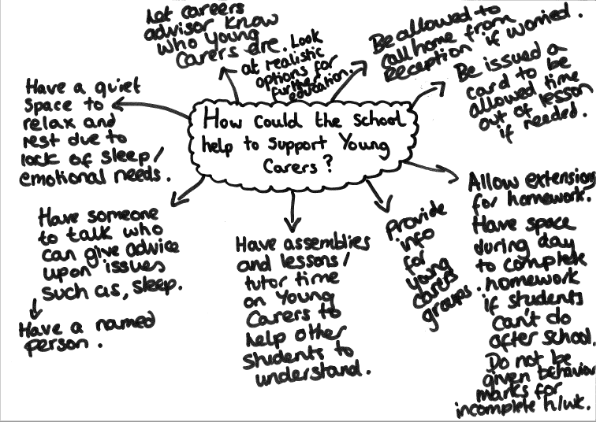

Example C

What we expect from Young Carers | What Young Carers can expect from us
To take part as fully as possible in lessons and opportunities offered in school. | Ensure that Young Carers is a topic covered in tutor time activities at least yearly, and that it forms part of assemblies/ Communication and Culture lessons where possible.  Deliver staff training on the topic as regularly as is necessary to keep staff informed about procedures.  Make staff aware, with permission from the Young carer and their family, when circumstances are likely to interfere with lessons and/or homework.  Inform Careers Advisor about any Young Carers and offer them 1:1 careers advice about realistic future opportunities.
Tell us in advance of deadlines if there are issues completing homework. | Allow agreed-upon extensions for homework tasks where possible.  Support students to complete homework during the school day (YC group on a Tuesday lunch time; supervised study during form times on agreed days with (PP Coordinator); have a space where YCs can come to do homework during any break or lunch time).  Avoid issuing negative points on Go4Schools if extension given for homework for this reason.
Make us aware of any changes to your caring role. | Allow use of Young Carers card when necessary to exit lessons for a few minutes.  Allow use of mobile phone in a designated area (e.g. inclusion office, wellbeing office) and/or contact home from reception if worried during the school day.  If necessary, meet with Young Carer (and parents/guardians) to discuss further support.
Let us know if you need more support. | We have 3 staff named as Young Carer Leads who can provide support in the form of weekly meetings (Tuesday lunch times in N26), advice/awareness, and who can be approached in person if you have a problem relating to your caring role.  There is an email group which will be used to communicate information about meetings, trips, etc. and which can be used by any Young Carers or potential Young Carers to contact designated staff or ask questions relating to being a Young Carer (youngcarers@****.net).  We can provide contact details and information about local Young Carers groups via students and staff contacts.

Example D

At .......................... School we believe all young people have a right to an education, regardless of their situation at home. When a young person has a caring responsibility they may need extra support to help them get the most out of school. We define a Young Carer as a young person who has caring responsibilities for a family member with a disability, health condition or substance misuse issue. Young carers may provide physical care, personal care, help with medication or practical tasks, or provide emotional support. This policy outlines how we will seek to identify, raise awareness of and offer support to any pupil who looks after someone at home. We are working in conjunction with the Young Carers Project at The Carers Centre for Brighton & Hove to provide this support.
Our School:
- Has a member of staff with special responsibility for young carers, and informs all new students who the member of staff is and what they can do to help. They are known as the Young carers lead (or other appropriate title).

- Will provide training and information to staff members on how to identify young carers and signpost them to the relevant support.

- Will proactively identify young carers and raise awareness of the issues they face as well as the support that is available (for example during form/tutor time, assemblies, PSHE sessions)

- Will provide a safe and confidential space for peer support groups, over seen by a member of staff, allowing young carers in the school to provide emotional support to each other regarding their caring role.

- Makes referrals to the Young Carers Project where appropriate and with the family and young person’s permission.

- Welcomes visits from the Young Carers Project to work with pupils referred for support so they can meet in a safe setting for 1:1 support sessions.

- Will provide information on our support for young carers on our website for current and prospective pupils and parents.

- Will consider alternatives if a young carer is unable to attend extra curricular activities due to their caring role.

- Will seek to provide alternatives if a young carer is unable to attend school because of their caring commitment.

- Will allow young carers access to their mobiles to contact home during breaks and lunchtimes.

- Has information about young carers available at prospective open days, and proactively asks about caring responsibilities during the admissions process.

- Is physically accessible and has accessible information available to parents who have mobility or communication difficulties.

- Will not make assumptions about family members with disabilities, mental and physical health conditions or substance misuse issues, or label young people and their families.

- Respects the young person’s right to privacy and only shares information on them and their family with people who need to know. Their home situation and caring role will not be discussed in front of their peers.

- Treats young carers in a sensitive and child-centred way, upholding confidentiality. The young person’s caring role is acknowledged and respected.

- Includes young carers in any existing transition package so that relevant support is highlighted to the young person.

Examples of whole-school models of support for young carers
Example A – Taken from ‘Supporting Young Carers: A resource for schools’;
Carers Trust, The Children’s Society, www.youngcarers.info

