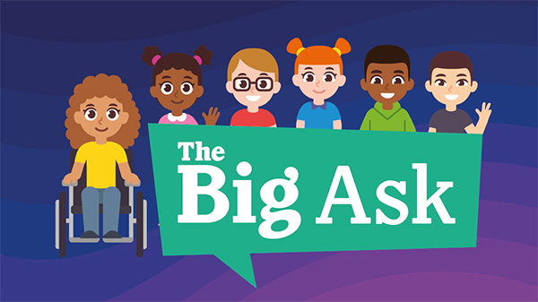

Get your child’s voice heard and make a difference

The Children’s Commissioner for England, Dame Rachel de Souza, has launched a once-in-a-generation review of children’s lives.

It’s called ‘The Childhood Commission’ and it will identify the barriers preventing children reaching their full potential and propose policy solutions to address them.

At its heart is ‘The Big Ask’ – the largest ever consultation held with children.
In this survey the Children’s Commissioner is asking children what they think is important for their future and what is holding them back. The Children’s Commissioner will use the results to show the Government what children think and what they need to live happier lives.

This week we will be asking children in years 2-6 to take part in the survey in class with their teacher/complete the survey as homework (delete as appropriate). Taking part in the survey is optional and children do not need to answer the questions if they don’t want to.

For younger children in years R and 1 (aged 4-5) there is a survey which they can complete with their parent.

It’s an exciting opportunity to help us think big and it’s a chance for every child in England to have their voice heard.

Find out more and take part

