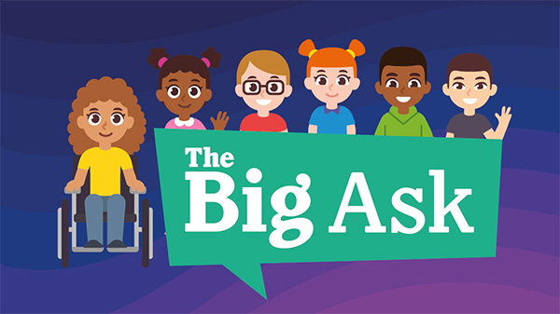

Get your child’s voice heard and make a difference

The Children’s Commissioner for England, Dame Rachel de Souza, is launching a once-in-a-generation review of children’s lives.

It’s called ‘The Childhood Commission’ and it will identify the barriers preventing children reaching their full potential and propose policy solutions to address them.

At its heart is ‘The Big Ask’ – the largest ever consultation held with children.
In this survey the Children’s Commissioner is asking children and young people what they think is important for their future and what is holding young people back. The Children’s Commissioner will use what children and young people tell her to show the Government what they think and what they need to live happier lives.

It’s an exciting opportunity to help us think big and it’s a chance for every child in England to have their voice heard.

Find out more and take part

